### **Communities**

**Question 1**:

For the following graph:

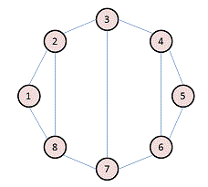Write the adjacency matrix A, the degree matrix D, and the Laplacian matrix L. For each, find the sum of all entries and the number of nonzero entries.

Adjacency matrix A

|  |  |  |  |  |  |  |  |  |
| --- | --- | --- | --- | --- | --- | --- | --- | --- |
|  | **1** | **2** | **3** | **4** | **5** | **6** | **7** | **8** |
| **1** | 0 | 1 | 0 | 0 | 0 | 0 | 0 | 1 |
| **2** | 1 | 0 | 1 | 0 | 0 | 0 | 0 | 1 |
| **3** | 0 | 1 | 0 | 1 | 0 | 0 | 1 | 0 |
| **4** | 0 | 0 | 1 | 0 | 1 | 1 | 0 | 0 |
| **5** | 0 | 0 | 0 | 1 | 0 | 1 | 0 | 0 |
| **6** | 0 | 0 | 0 | 1 | 1 | 0 | 1 | 0 |
| **7** | 0 | 0 | 1 | 0 | 0 | 1 | 0 | 1 |
| **8** | 1 | 1 | 0 | 0 | 0 | 0 | 1 | 0 |

Degree matrix

|  |  |  |  |  |  |  |  |  |
| --- | --- | --- | --- | --- | --- | --- | --- | --- |
|  | **1** | **2** | **3** | **4** | **5** | **6** | **7** | **8** |
| **1** | 2 | 0 | 0 | 0 | 0 | 0 | 0 | 0 |
| **2** | 0 | 3 | 0 | 0 | 0 | 0 | 0 | 0 |
| **3** | 0 | 0 | 3 | 0 | 0 | 0 | 0 | 0 |
| **4** | 0 | 0 | 0 | 3 | 0 | 0 | 0 | 0 |
| **5** | 0 | 0 | 0 | 0 | 2 | 0 | 0 | 0 |
| **6** | 0 | 0 | 0 | 0 | 0 | 3 | 0 | 0 |
| **7** | 0 | 0 | 0 | 0 | 0 | 0 | 3 | 0 |
| **8** | 0 | 0 | 0 | 0 | 0 | 0 | 0 | 3 |

|  |  |  |  |  |  |  |  |  |
| --- | --- | --- | --- | --- | --- | --- | --- | --- |
|  | **1** | **2** | **3** | **4** | **5** | **6** | **7** | **8** |
| **1** | 2 | -1 | 0 | 0 | 0 | 0 | 0 | -1 |
| **2** | -1 | 3 | -1 | 0 | 0 | 0 | 0 | -1 |
| **3** | 0 | -1 | 3 | -1 | 0 | 0 | -1 | 0 |
| **4** | 0 | 0 | -1 | 3 | -1 | -1 | 0 | 0 |
| **5** | 0 | 0 | 0 | -1 | 2 | -1 | 0 | 0 |
| **6** | 0 | 0 | 0 | -1 | -1 | 3 | -1 | 0 |
| **7** | 0 | 0 | -1 | 0 | 0 | -1 | 3 | -1 |
| **8** | -1 | -1 | 0 | 0 | 0 | 0 | -1 | 3 |

**A has 22 non zero entries**

**D has 8 non zero entries**

**L has 30 non zero entries**

**The sum of the entries of A is 22**

**The sum of the entries of D is 22**

**The sum of the entries of L is 0**

**Question 2**:

Consider the following undirected graph (i.e., edges may be considered bidirectional):

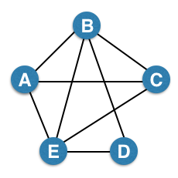

Run the "trawling" algorithm for finding dense communities on this graph and find all complete bipartite subgraphs of types K3,2 and K2,2. Note: In the case of K2,2, we consider {{W, X}, {Y, Z}} and {{Y, Z}, {W, X}} to be identical.



|  |  |
| --- | --- |
| Item sets | |
| A | B, E, C |
| B | A, E, D, C |
| C | B, A, E |
| D | B, E |
| E | A, B, C, D, E |

K3,2 and K2,2

|  |  |
| --- | --- |
| Item | support |
| A | 3 |
| B | 4 |
| C | 3 |
| D | 2 |
| E | 4 |

|  |  |
| --- | --- |
| Item | support |
| B, E | 3 |
| B, C | 2 |
| E, C | 2 |
| A, E | 2 |
| A, D | 2 |
| A, C | 2 |
| E, D | 1 |
| D, C | 2 |
| B, A | 2 |
| B, D | 1 |

1 Bipartite graph



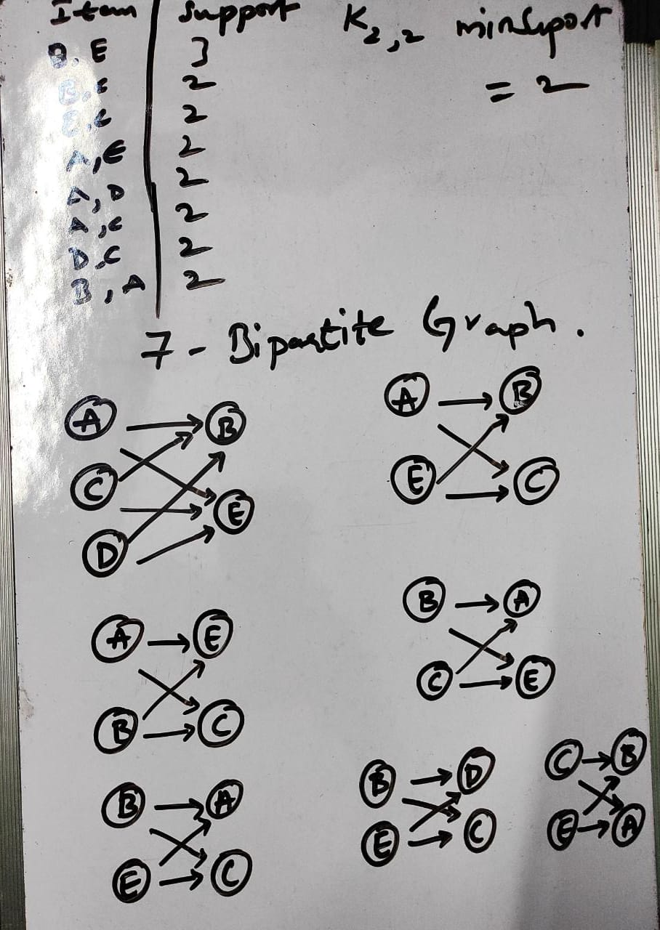

**Question 3**:

We fit AGM to the network on the left, and found the parameters on the right:

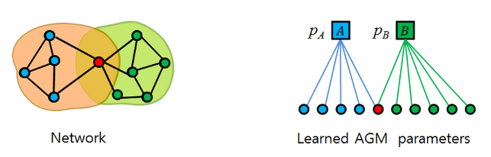

Find the optimal values for pA and pB.

Pa = Number of edges in the network / Total possible number of edges = 7/5c2 = 7/10.

Pb = Number of edges in the network / Total possible number of edges = 9/6c2 = 9/15.